ASSIGNMENT-13.3
Name: I.Harshith
HT. No: 2303A51624
Batch: 08
Lab 13: Code Refactoring Using AI Assistance Improving Legacy Code for
Readability, Maintainability, and Performance
Task 1: Refactoring – Removing Code Duplication
Objective
To eliminate repeated logic by extracting reusable functions.
Task Description
Use AI assistance to refactor a legacy Python script that contains repeated
blocks of code calculating the area and perimeter of rectangles.
Starter (Legacy) Code
# Legacy script with repeated logic
print("Area of Rectangle:", 5 * 10)
print("Perimeter of Rectangle:", 2 * (5 + 10))
print("Area of Rectangle:", 7 * 12)
print("Perimeter of Rectangle:", 2 * (7 + 12))
print("Area of Rectangle:", 10 * 15)
print("Perimeter of Rectangle:", 2 * (10 + 15))
Expected Outcome
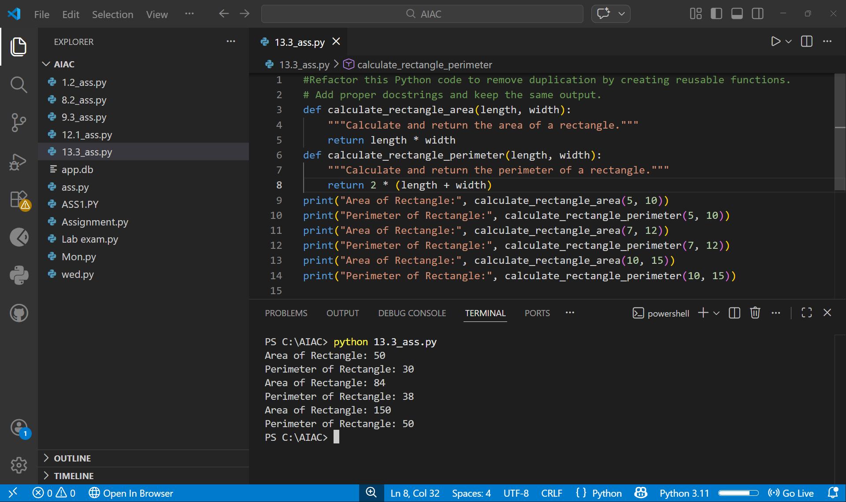
Task 2: Refactoring – Optimizing Loops and Conditionals
Objective
To improve performance by replacing inefficient nested loops with optimized
structures.
Task Description
Use AI to analyze and refactor a script that checks the presence of elements
using nested loops.
Starter (Legacy) Code
names = ["Alice", "Bob", "Charlie", "David"]
search_names = ["Charlie", "Eve", "Bob"]
for s in search_names:
found = False
for n in names:
if s == n:
found = True
if found:
print(f"{s} is in the list")
else:
print(f"{s} is not in the list")
Expected Outcome
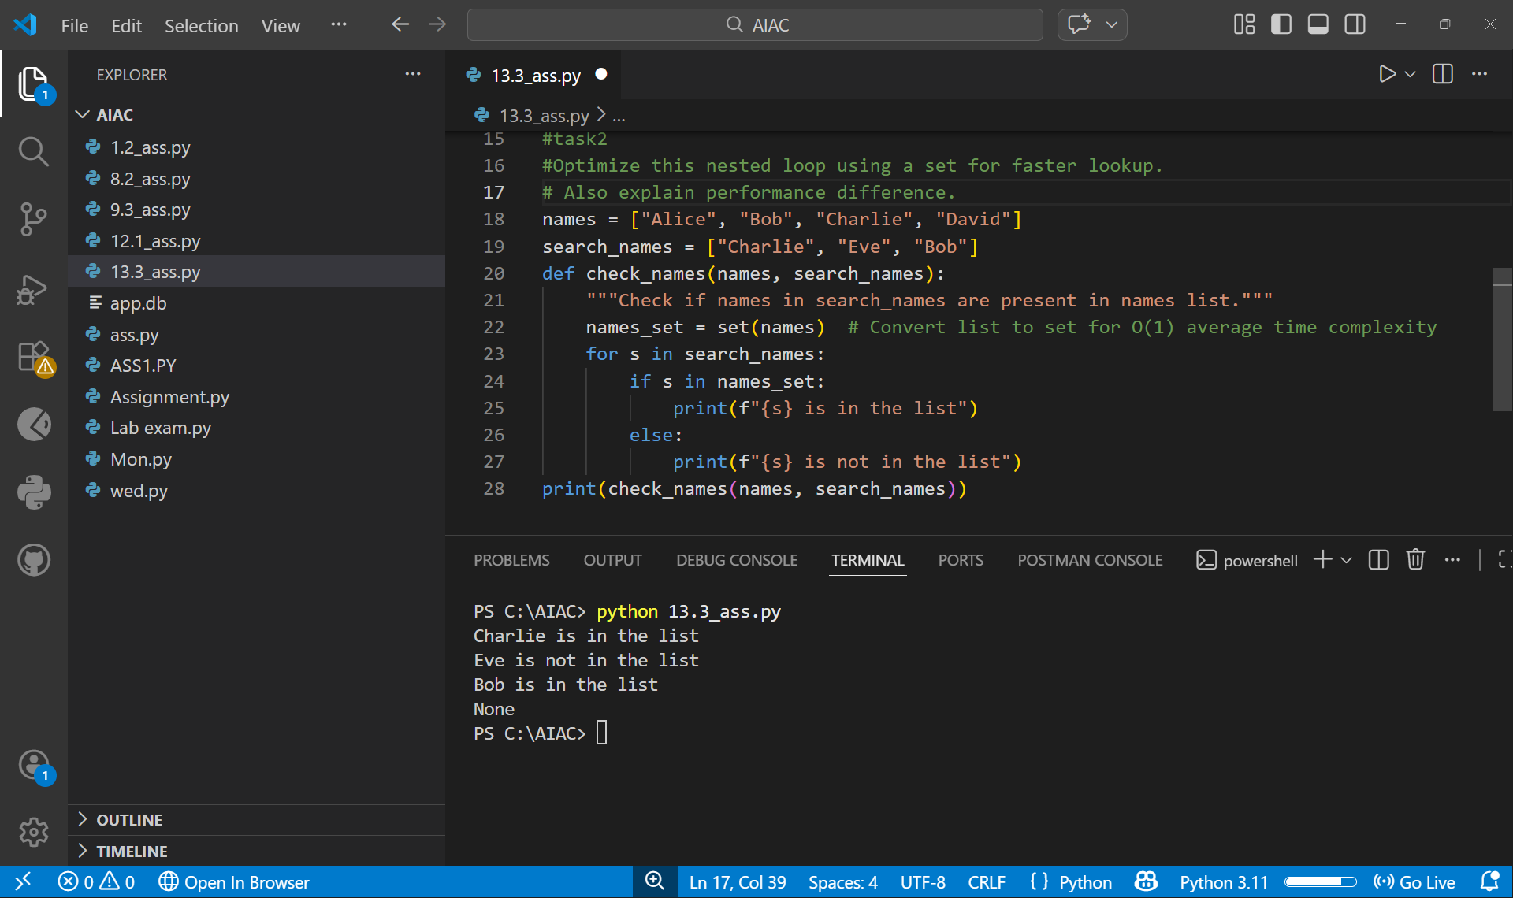
Task 3: Refactoring – Extracting Reusable Functions
Objective
To modularize code by extracting calculations into reusable functions.
Task Description
Refactor a legacy script where price and tax calculations are written inline.
Starter (Legacy) Code
price = 250
tax = price * 0.18
total = price + tax
print("Total Price:", total)
price = 500
tax = price * 0.18
total = price + tax
print("Total Price:", total)
Expected Outcome
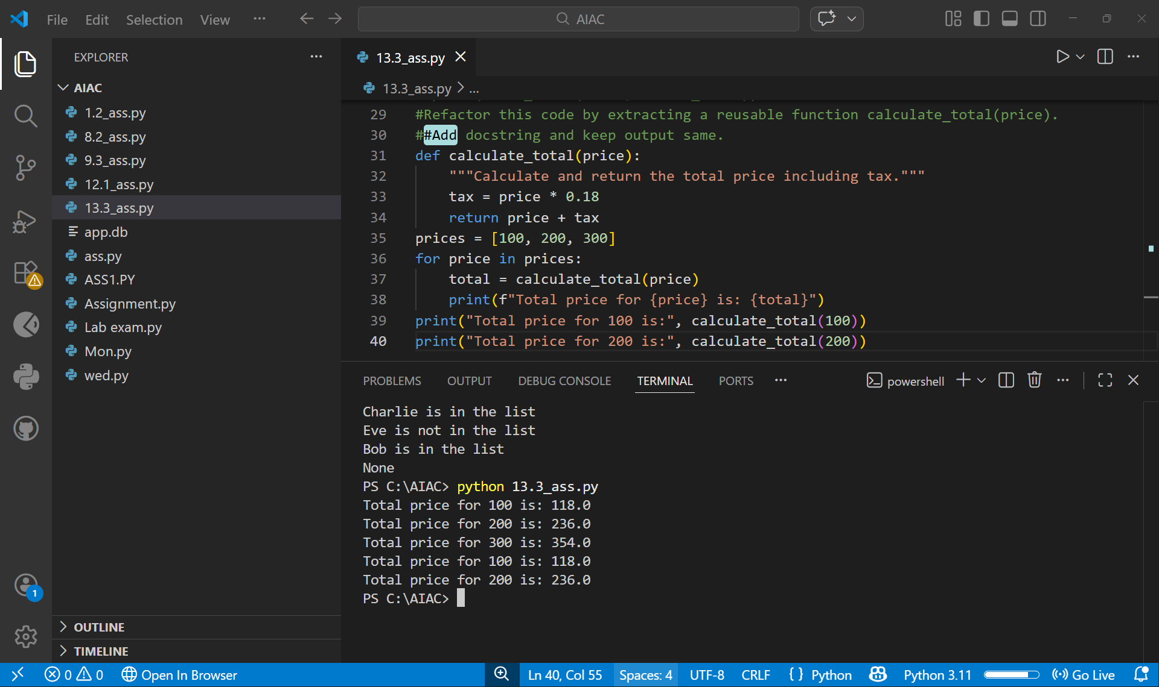
Task 4: Refactoring – Replacing Hardcoded Values with Constants
Objective
To improve maintainability by replacing magic numbers with named constants.
Task Description
Use AI to identify hardcoded values and replace them with constants.
Starter (Legacy) Code
print("Area of Circle:", 3.14159 * (7 ** 2))
print("Circumference of Circle:", 2 * 3.14159 * 7)
Expected Outcome
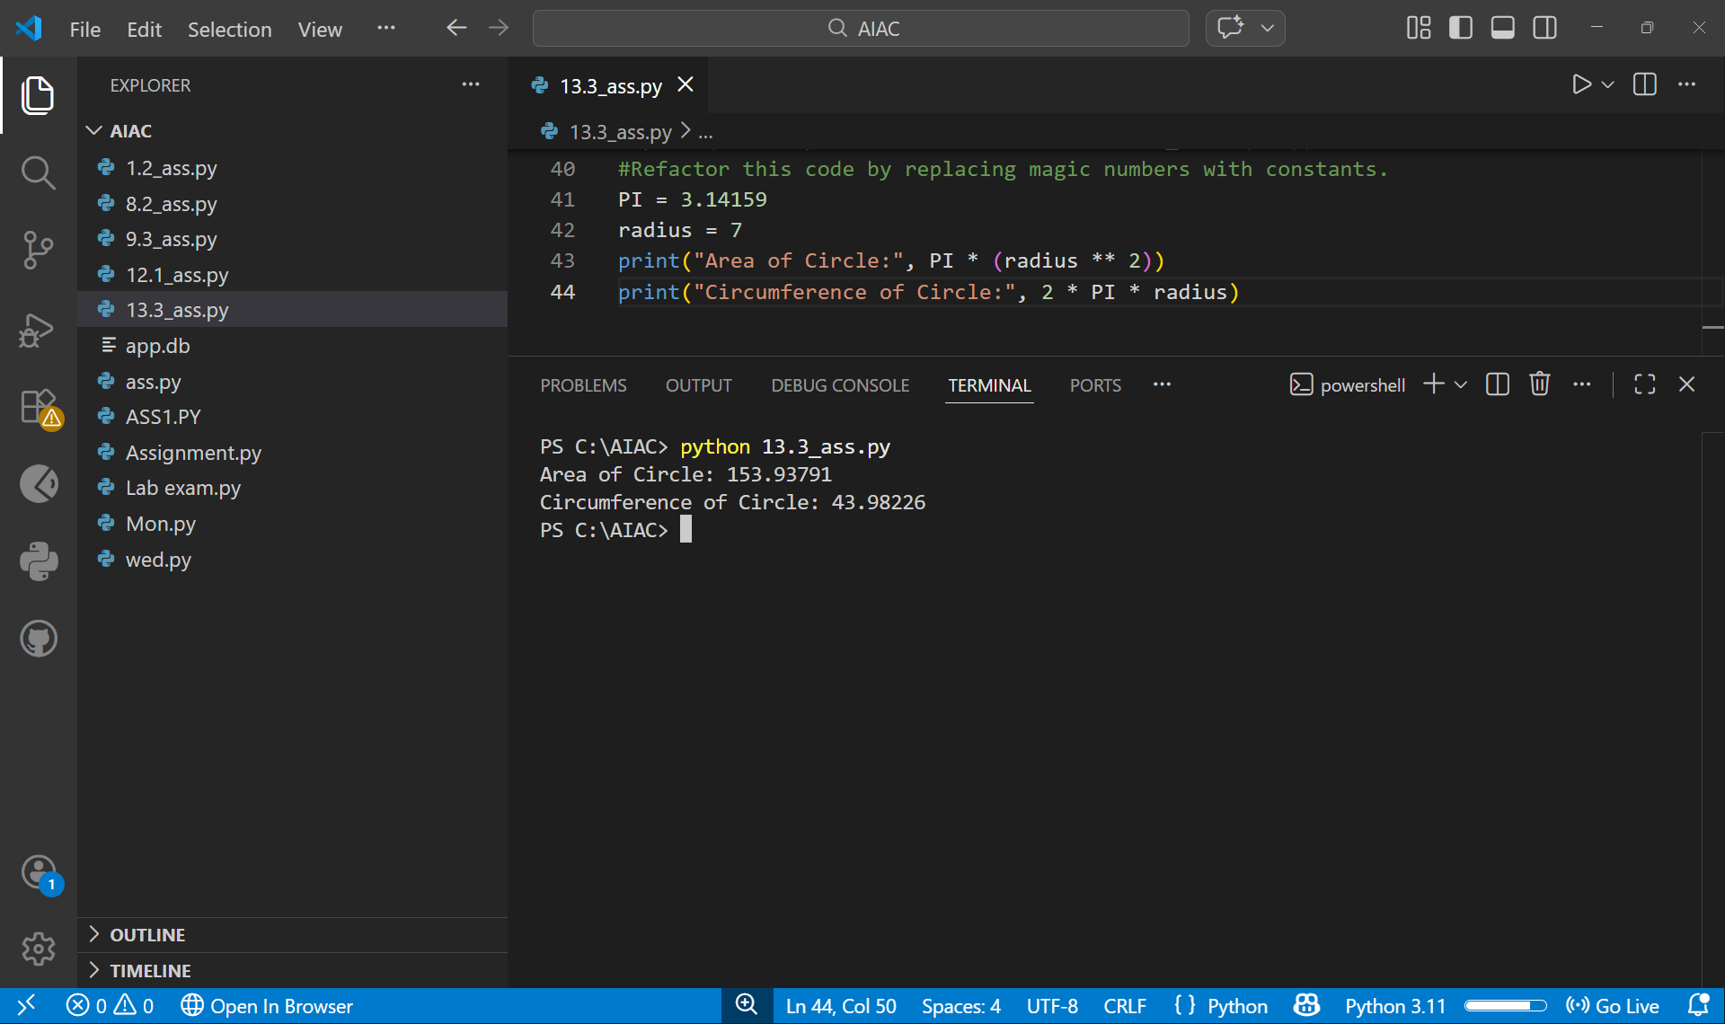
Task 5: Refactoring – Improving Variable Naming and Readability
Objective
To enhance readability using descriptive variable names and comments.
Task Description
Refactor a script with unclear variable names.
Starter (Legacy) Code
a = 10
b = 20
c = a * b / 2
print(c)
Expected Outcome
